**Evaluation Metrics in Machine Learning**

**Types of classification matrix :**

**Accuracy :**

**The numbers of accurate prediction out of total samples given to model .**

**Precision :   
precision it tells us numbers of positive prediction are actually correct predict by the model**

**Precision=TP/FP+TP​**

**Recall :  
recall tells us the numbers of true predictions out of actual true values**

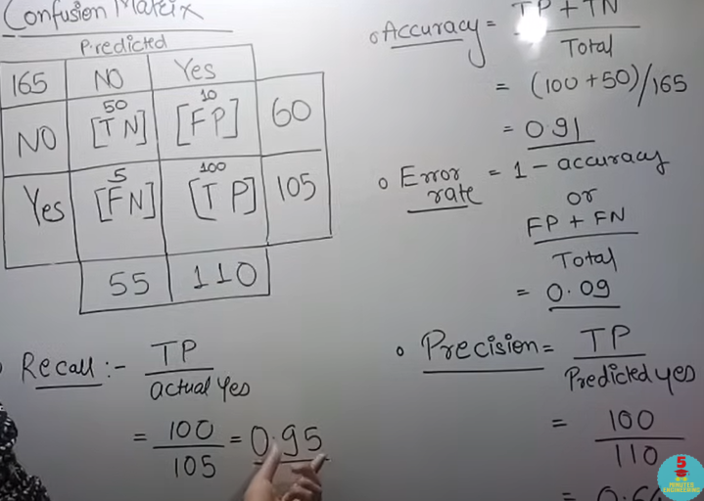

**F1 Score :**

**Some times data set balance nai hota to precision and recall bhi achy sy kam nai krta es situation ma hum enka harmonic mean (HM) nikalty hain it is the reciprocal of precision and recall**

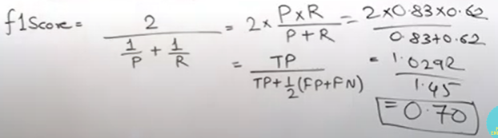

**Linear Regression:**

**It is a type of supervised learning ,in supervised learning we given the target values with feature values to model**

**We mostly used the linear regression in continuous values**

**In linear regression the relation b/w the dependent and independent is linear and values are continuous**

**X increase**

**Y increase**

**Residual error:**

**The distance from the best fit line   
the difference b/w the actual and predicted value**

**Best fit line: Best fit line with minimum minimul error**

**Tokenization:**

**In Tokenization we split the peragraph or sentence into single word or characters .**

**It make easy to ML model for learning**